CHANDINI T R
1NT20IS403

1.Create a Flutter App to demonstrate the usage of

SafeArea

Main.dart

import 'package:flutter/material.dart';
void main() {
runApp( MaterialApp(
home:Text(
'Without SafeArea',
textAlign: TextAlign.center,
style: TextStyle(
fontSize:40,
fontWeight: FontWeight.w800,
color:Colors.deepOrangeAccent,
),
),
));
}

Widget_test

import 'package:flutter/material.dart';
import 'package:flutter_test/flutter_test.dart';
import 'package:scaffold/main.dart';
void main() {
testWidgets('Counter increments smoke test', (WidgetTester tester) async {
// Build our app and trigger a frame.
await tester.pumpWidget(MaterialApp());
// Verify that our counter starts at 0.
expect(find.text('0'), findsOneWidget);
expect(find.text('1'), findsNothing);
// Tap the '+' icon and trigger a frame.
await tester.tap(find.byIcon(Icons.add));
await tester.pump();
// Verify that our counter has incremented.
expect(find.text('0'), findsNothing);
expect(find.text('1'), findsOneWidget);
});
}
OUPUT

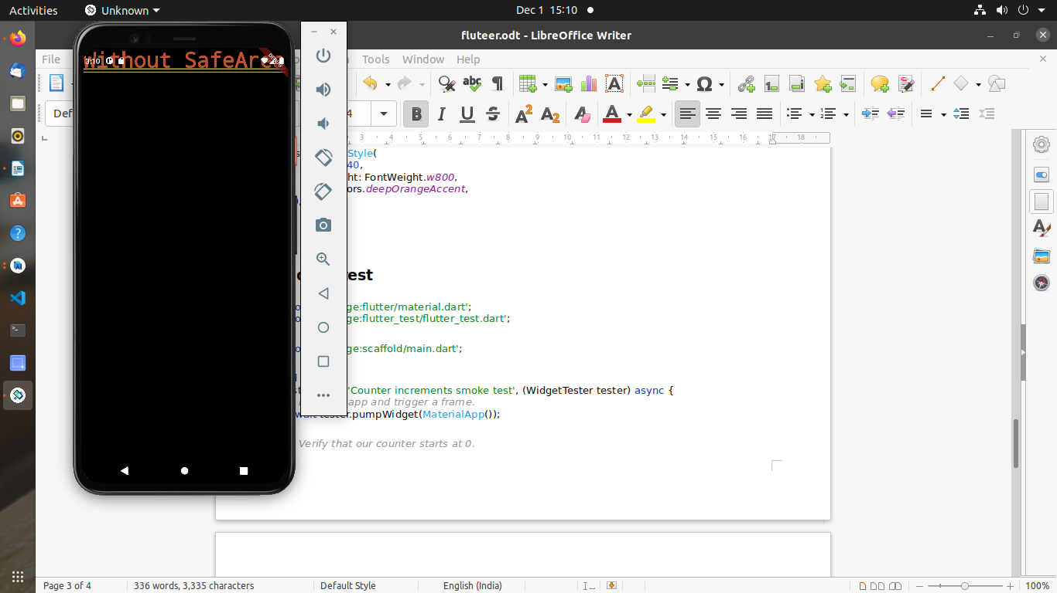

2.Create a Flutter App to demonstrate the usage of Scaold

Main.dart

import 'package:flutter/material.dart';
void main() {
runApp(MaterialApp(
home:Scaffold(
appBar: AppBar(
title:Text("First Flutter App"),
),
body: Center(
child: Text(
'this is a first App',
style: TextStyle(
fontSize: 40.0,
fontStyle: FontStyle.italic,
fontWeight: FontWeight.bold,
),
),
),
),
),
);
}
Widget_set
import 'package:flutter/material.dart';
import 'package:flutter_test/flutter_test.dart';
import 'package:scaffhold/main.dart';
void main() {
testWidgets('Counter increments smoke test', (WidgetTester tester) async {
// Build our app and trigger a frame.
await tester.pumpWidget(MaterialApp());
// Verify that our counter starts at 0.
expect(find.text('0'), findsOneWidget);
expect(find.text('1'), findsNothing);
// Tap the '+' icon and trigger a frame.
await tester.tap(find.byIcon(Icons.add));
await tester.pump();
// Verify that our counter has incremented.
expect(find.text('0'), findsNothing);
expect(find.text('1'), findsOneWidget);
});
}
OUTPUT
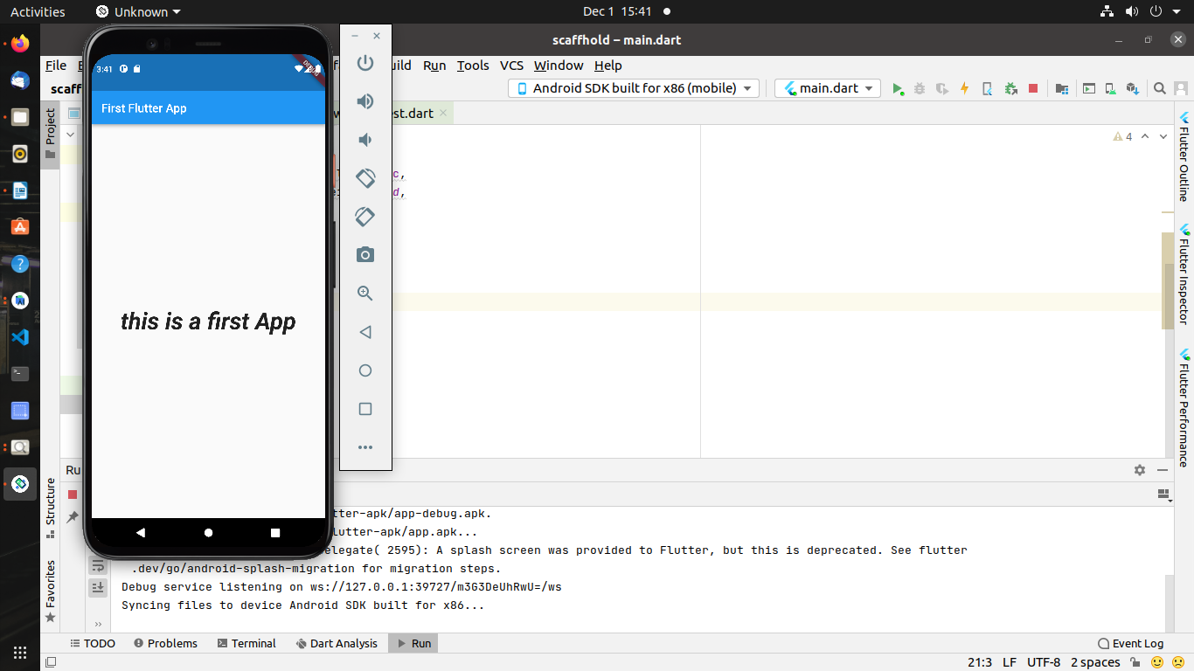

3.Additional Program:Combining Scaold and SafeArea

Main.dart
import 'package:flutter/material.dart';
void main() {
runApp(MaterialApp(
home:Scaffold(
appBar: AppBar(
title:Text(
'Scaffold safeArea'
),
),
body:Container(
child: SafeArea(
child: Center(
child: Text(
'This is a sample Text'
),
),
),
),
),
));
}
Widget_test
import 'package:flutter/material.dart';
import 'package:flutter_test/flutter_test.dart';
import 'package:scaffhold/main.dart';
void main() {
testWidgets('Counter increments smoke test', (WidgetTester tester) async {
// Build our app and trigger a frame.
await tester.pumpWidget(MaterialApp());
// Verify that our counter starts at 0.
expect(find.text('0'), findsOneWidget);
expect(find.text('1'), findsNothing);
// Tap the '+' icon and trigger a frame.
await tester.tap(find.byIcon(Icons.add));
await tester.pump();
// Verify that our counter has incremented.
expect(find.text('0'), findsNothing);
expect(find.text('1'), findsOneWidget);
});
}
Output:

